25-05-2024

**Simple Notifciation service ( SNS )**

Notification Mechanism

1. Notification from AWS Native services to your email >>>> SNS

2. Notification from AWS Native services to your SMS >>>> SNS

3. Notification from AWS Native service when there is any action >>> SNS

4. Notification from one AWS service to another AWS service >>> SNS

SNS with S3

https://docs.aws.amazon.com/AmazonS3/latest/userguide/ways-to-add-notification-config-to-bucket.html#step1-create-sns-topic-for-notification

Step 1 - Create a SNS topic if not already , Go to AWS Console and open SNS service

Check the Topics are created or Noe if not create the topic

Choose Standard

Give a name

Then Click on create topic rest all leave it .

Topic created

Step 2 - Add a Subscriptions >>> email and SMS >>> get that verified

Select protocol as email and endpoint email address

Click on create subscription

Go to your email and and click on pendimg subscription

Now Status is showing confirmed.

Now copy the url and paste in browser and copy the

<https://docs.aws.amazon.com/AmazonS3/latest/userguide/ways-to-add-notification-config-to-bucket.html#step1-create-sns-topic-for-notification>

Copy the access policy

From the url and paste in the SNS policy

Edit SNS , go to access policy and click on edit

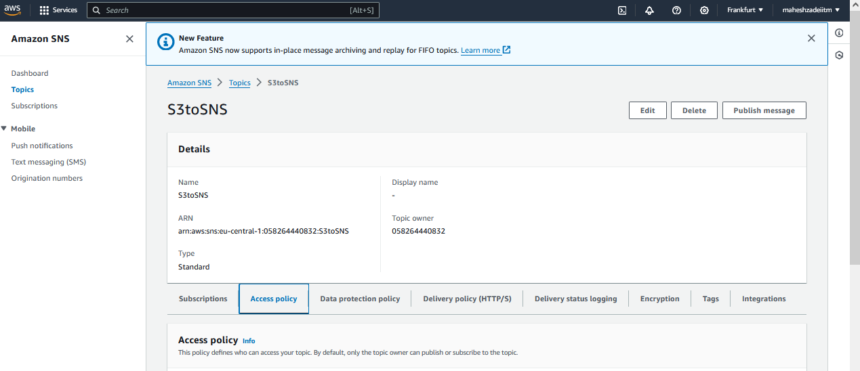

Step 3 - Edit your SNS and go to the Access Policy

Step 4 - Copy the policy from the above URL

And replace the policy copy and paste

And update below parameters

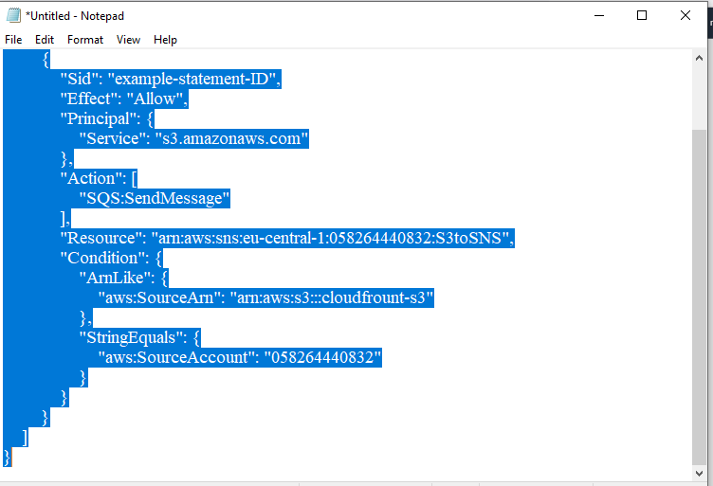

SNS-topic-ARN >>>> SNS ARN

arn:aws:s3:*:*:bucket-name >>> S3 ARN

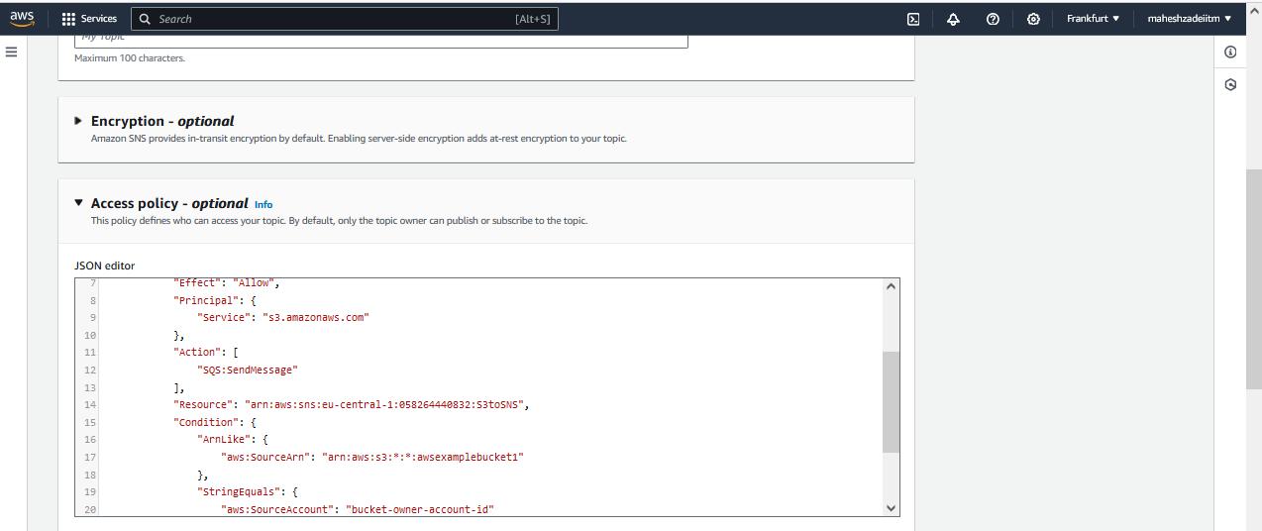

bucket-owner-account-id >>>> your AWS Account ID

I have used below policy

{

"Version": "2008-10-17",

"Id": "__default_policy_ID",

"Statement": [{

"Sid": "__default_statement_ID",

"Effect": "Allow",

"Principal": {

"AWS": "*"

},

"Action": [

"SNS:GetTopicAttributes",

"SNS:SetTopicAttributes",

"SNS:AddPermission",

"SNS:RemovePermission",

"SNS:DeleteTopic",

"SNS:Subscribe",

"SNS:ListSubscriptionsByTopic",

"SNS:Publish"

],

"Resource": "arn:aws:sns:eu-central-1:058264440832:S3toSNS",

"Condition": {

"StringEquals": {

"AWS:SourceOwner": "058264440832"

},

"ArnLike": {

"AWS:SourceArn": "arn:aws:s3:::cloudfrount-s3"

}

}

}]

}

And update at the SNS Access policy >>> Save

Step 5 >>> now go to your Bucket >>>>> Properties >>>>> Event notifications >>>>> Create event notification

Event name >>>> s3update

Event types >>> Check all the boxes as your want

Destination >>>>> SNS topic

Specify SNS topic >>>> Enter SNS topic ARN >>>> Update your SNS ARN

Copy SNS ARN

Save Changes

SNS is DONE?

NO

- SNS Vs SQS

- S3 notification to the SNS

- etc